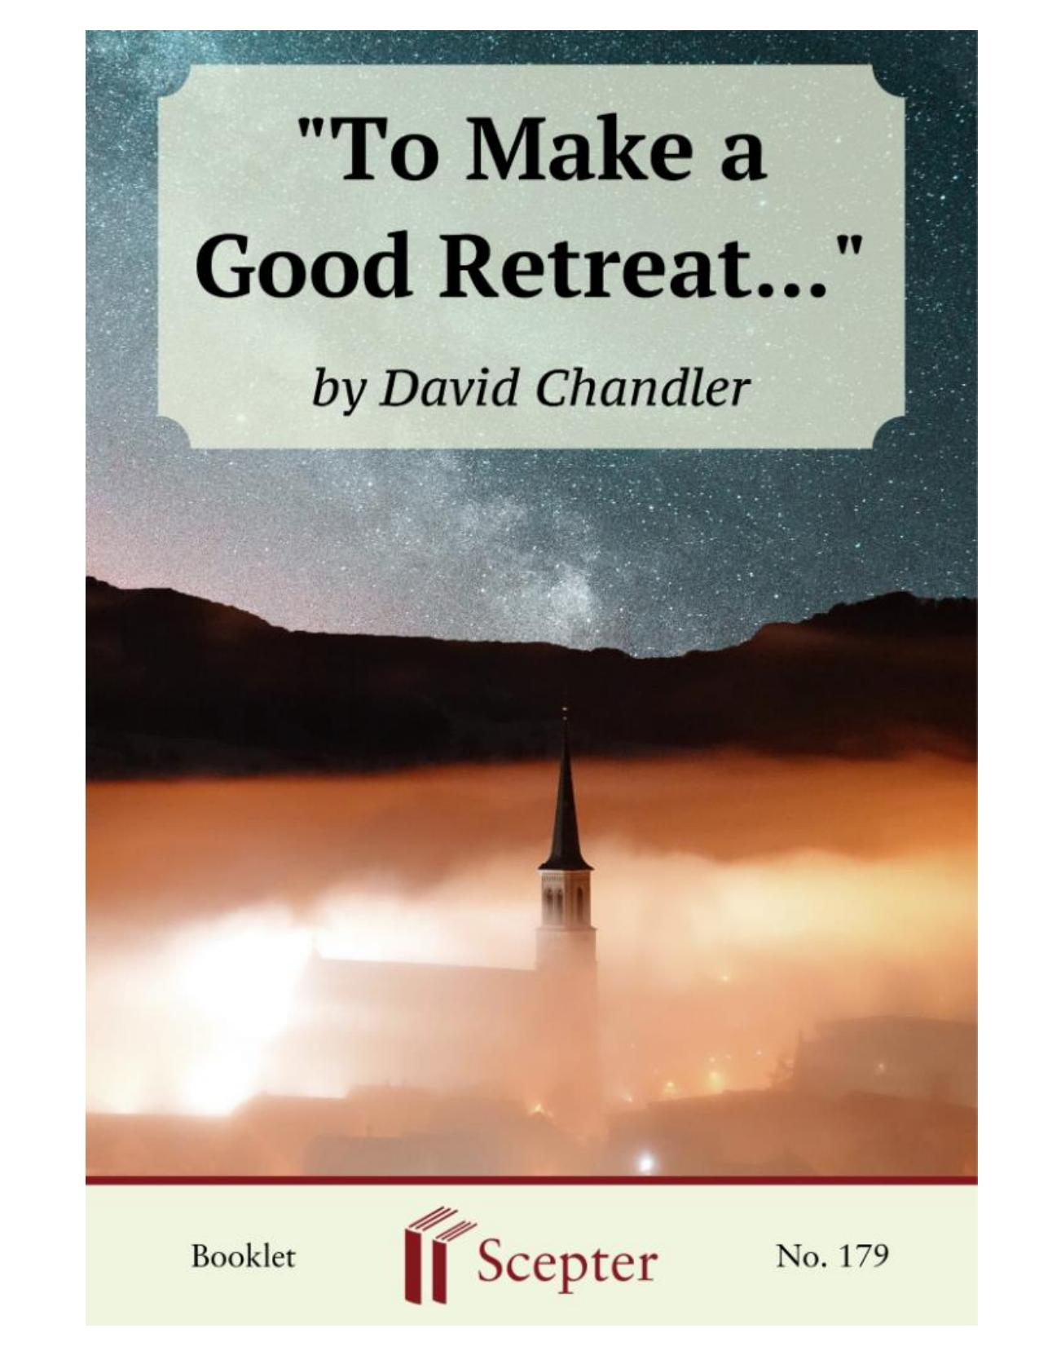
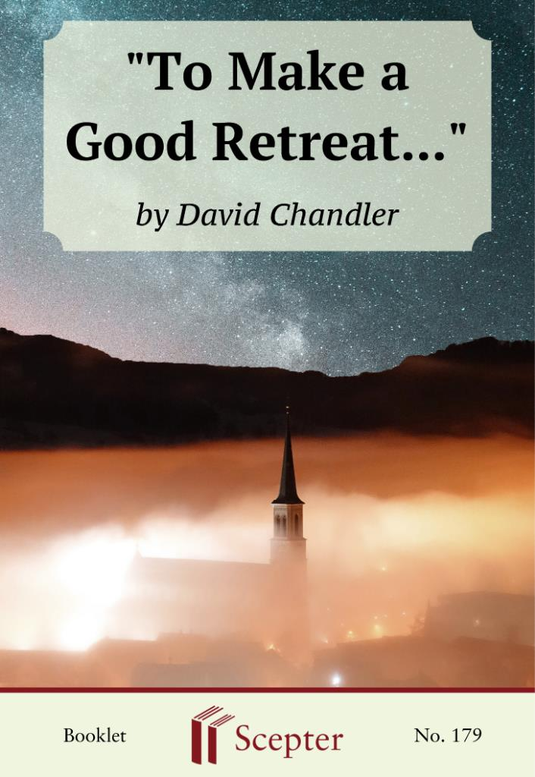

SCEPTER BOOKLETS

“To Make a Good Retreat…”

By David Chandler

Scepter Publishers
PO Box 360694,
Strongsville, Ohio 44136

Toll Free: 800-322-8773 (US & Canada only) Tel: 212-354-0670
Fax: 646-417-7707

info@scepterpublishers.org

www.scepterpublishers.org

©1988 Scepter Publishers
Second Edition, © 2019
Booklet and Cover design by Parker Eidle Booklet Number: 179

© Scepter Publishers, Inc. This information protected by copyright of Scepter Publishers, Inc., New York, NY USA. It is for the free use of readers and we encourage you to redistribute this without permission. None of this information can be sold, either in electronic or print form, unless permission has been obtained from Scepter Publishers, Inc. Direct all inquiries to
info@scepterpublishers.org.

CONTENTS

Introduction 1
God’s Purpose for You 3
What’s It About 4
Their Own “Reasons” 5
In Silence and Prayer 6
Personal Conversation 7
Reading and Reflection 9
Repentance 10
Resolution 11
New Life as a Child of God 14
The Prodigal Son 15
“TO MAKE A GOOD RETREAT…”

1

INTRODUCTION

You need to make a good retreat.
From time to time in life, everyone does.
The fact is, though, that few people really understand why until they have made one. The experience of a few days spent deeply in the presence of God, praying and reflecting on our life's direction, gives an incomparable richness to our vision of things. A well-made retreat brings peace, vitality, and a youthful confidence: a singular regaining of the happiness we knew as children, and a taste of the joyful sense of adventure that all the saints have experienced.
Who doesn't need this?
Perhaps you sense this need in yourself already. And this is why you've begun to read these pages. You have decided to make a retreat, and you want to make it well.
Or, on the other hand, perhaps you haven't yet made such a decision.
Someone who's close to you—a spouse, a friend, a spiritual director—has suggested that you really ought to make a retreat, or positively need to make one, and you'd like to think the matter over.
In either case, read on. The purpose of these pages is simply this: to lead you into making the very best retreat that you have ever experienced, and to help you turn a few days into an important turning point in your life, one that leads to your own happiness and directly affects the happiness of the people whom you love most.
This may strike you as quite a high-reaching ambition. Unrealistic, you may think. But it isn't. The fact is that God himself has ambitions for your happiness that you've scarcely begun to imagine. And his will for you, for the rest of your life on Earth, is what a retreat is all about. The Gospels are filled with stories of people like you, people who discovered, often to their astonishment, new and unsuspected directions for their lives when they opened themselves to Christ's friendship.
Openness to God's love for us—to see clearly how our past and future fit his plan for our happiness—forms the meaning and measure of a well-made retreat. This profoundly important perspective is what awaits you.

CATHOLIC BOOKS FOR SPIRITUAL GROWTH
“TO MAKE A GOOD RETREAT…”

2

There is so much to think about on a retreat, and the allotted time is so brief, that you must get off to a good start. Our Lord does not need much time, experience shows, to work his changes in people. But, like the people you meet in the Gospels, you too have to open your mind and heart for this encounter with his mercy. You have to stop what you're doing and go to meet him halfway.
As you set out on the first days of your retreat, make your prayer be the prayer of blind Bartimeus, sitting helplessly on the roadside: "Lord, let me see!"

CATHOLIC BOOKS FOR SPIRITUAL GROWTH
“TO MAKE A GOOD RETREAT…”

3

GOD’S PURPOSE FOR YOU

"For my thoughts are not your thoughts nor your ways my ways,” says the Lord. “For as the heavens are exalted above the earth, so are my ways exalted above your ways, and my thoughts above your thoughts" (Is 55:8-9).
People have all sorts of personal reasons for making a retreat. As you look around you on your arrival, you will find people who have come for motives all their own.
Some, perhaps most, have come mainly to get a much-appreciated rest from the rush and jangle of everyday life. They're after some peace and quiet for a change. Others want a distant vantage point to set their thoughts and affairs in order, whatever that might be; they feel a need to rearrange, somehow, their priorities. Some others have given in at last to the urging, maybe even the relentless persistence, of someone close to them. A handful come to deepen their faith; they need spiritual strength to resolve some personal problem or even some serious crisis in their lives.
Whatever the case, it seems that most people really don't have a clear-cut set of reasons for coming. Somehow, through a tangle of circumstances, they find themselves brought here, about to begin a retreat.
At the outset, it is critical to understand one thing clearly: the reasons you thought you had for coming are not those of God. His reasons for bringing you here are vastly, infinitely above your own. God has used the circumstances of your life—your fatigue, your confusion, your problems, your loved ones, even a kind of shapeless curiosity—to draw you to himself.
He wants you here to experience his love for you deeply, maybe for the first time, during the course of this retreat.
God has contrived to bring you here, at this juncture of your life, because he has things vitally important to tell you. He wants you to set aside your "reasons," whatever they may be, to open your mind and heart to him alone: to learn what plans he has for you in the time remaining in your life.
God has planned this abrupt encounter with you to befriend you. But there's nothing new in this method of his. Look in the Gospels and you'll find people like yourself whose lives were touched with surprise when they first befriended Christ on their way.

CATHOLIC BOOKS FOR SPIRITUAL GROWTH
“TO MAKE A GOOD RETREAT…”

4

WHAT’S IT ABOUT

Take the young apostles, for example. Initially, it seems, they first approached our Lord out of mere youthful curiosity. For young people, curiosity is a readiness for new knowledge and for the possibility of adventure. Nathaniel, for example, found himself nagged by his friends to come and meet this Jesus of Nazareth; he came, apparently, to scoff in amusement. Matthew was startled to be called in the midst of his money-making affairs. For all of these young men, one thought filled their minds: What's all this about?
Bartimeus, the blind beggar, desperately sought relief from his personal misery. Overwhelmed with intractable personal problems, he called out to Christ for help. His faith and hope were as great as his troubles; he stretched out his hands to Christ in pleading supplication.
Nicodemus, a man advanced in age, approached our Lord cautiously.
In the twilight of his years, he seemed to be longing for truth about life and death. His was an existential search: What has my life been all about? What lies ahead for me?
The Samaritan woman at the well of Sichar had a more down-to-earth motive. Weighed down with the grimness of sin, she heavily went about her daily life's routine. It was water she sought, to cleanse herself and relieve her thirst. Cynical and downhearted, she came to a well; there, to her surprise, she met a stranger who shared her thirst.
Simon of Cyrene was different from these others. He was a pious pilgrim. With his sons Alexander and Rufus, he had traveled a thousand miles to fulfill a duty of religious piety. He was seeking to please God as well as he knew how. "Coming in from the country," perhaps with his bags still in his hands, he was engulfed by the raging crowd of a public execution. Some wretched criminal, covered with blood, staggered toward him and his family.
Which of these people is most like you?

CATHOLIC BOOKS FOR SPIRITUAL GROWTH
“TO MAKE A GOOD RETREAT…”

5

THEIR OWN “REASONS”

All of them, and many others in Scripture, had their own "reasons"
when they first met Christ. He, in his eternal mind, had other, higher plans for each of them. He set aside their reasons, as it were, and raised them to a new plane of experience. Their lives and his own became entwined.
The young apostles, swept away with love for him, went to the ends of the earth to spread the "good news" of their happiness. They had found a knowledge they had never dreamt of, and Christ gave the word “adventure”
a whole new meaning in history.
Bartimeus received his sight, and much more besides. His first vision was that of Christ's face, looking into his eyes with loving mercy. From that moment on, he became Christ's follower, expending his life in the praise of God.
Nicodemus was told, to his puzzlement, that he was to be born anew, that his life was only just beginning, and his greatest achievements lay ahead of him. On Golgotha, months later, he and Joseph of Arimathea underwent a profound transformation. When all around them were paralyzed with fear, as they had been before, they leaped into action to serve Jesus and his grieving mother. Their actions had the quality of youth: boldness, decisiveness, courageous loyalty. Nicodemus, in his love for Jesus, had begun life anew.
The Samaritan woman, startled by God's truth and offer of mercy, drew her neighbors and townspeople to the feet of the Savior. God's loving forgiveness turned the course of her life entirely.
And Simon, the pilgrim who had sought the service of God, took an intimate part in the central sacrifice of history, the Redemption of mankind.
His sons would enjoy, to the end of their lives, the memory of their father's unforeseen encounter with Jesus.
At the very outset of your retreat, then, you too may have your motives unclear and unsettled. No matter. It is God's motives that count. He is determined to embrace your mind and will. He has brought you to this retreat so that you, like these others, can rise to a new level of happiness in his loving friendship.

CATHOLIC BOOKS FOR SPIRITUAL GROWTH
“TO MAKE A GOOD RETREAT…”

6

IN SILENCE AND PRAYER

"Speak, Lord. Your servant is listening" (I Kings 3:10).
As you probably know, a retreat traditionally is made in silence. For many people this silence is one of its most attractive features. As someone has noted, most of us in this period of history live as though we were encamped in the middle of a carnival: surrounded by the clamor of entertainers and hawkers vying frantically for our attention. Small wonder that the peace of a retreat seems so welcome, a reward in itself.
For many other people, however, the quiet is a bit disquieting. The mind, unaccustomed to repose, fidgets to direct its attention someplace. But where? What is this silence for?
At the beginning of your retreat, you may be told as a matter of routine that you should keep silence to avoid distracting the others around you. This is certainly true but possibly misleading. Your silence is not merely a matter of courtesy. It is a matter of much deeper importance.
You keep silence for this reason: a retreat is not a group activity—it is meant to be made by each person alone. You, along with each of the other participants, are to spend these few days entirely alone in the presence of God. It is in this way that you can begin to speak with him, and grow to know him.
There is one central fact to life that the retreat brings to the forefront of your mind: someday you will leave this earthly life and meet God face to face, alone, just the two of you. The retreat is, so to speak, an introductory preparation for this transcendently important encounter. Christ's entire purpose in the Redemption was your own personal salvation. He suffered and died for you personally, by name; and he would have done this to save just one soul here on Earth, yours alone.
Your union with him at death is meant to be a reunion of intimate friends. Is that what it will be?

CATHOLIC BOOKS FOR SPIRITUAL GROWTH
“TO MAKE A GOOD RETREAT…”

7

PERSONAL CONVERSATION

This friendship, like any other, receives its initial life and later depth through personal conversation. On this retreat our Lord wants to spend time speaking with you in the same way that he did with the people of his time: with Nicodemus, and the Samaritan woman, and with repentant Peter as they walked by the shores of the lake.
God has called you to these days of silence so that you and he can talk intimately about the really important things in your life. This personal talk is, in a word, prayer.
So your prayer on this retreat is intended by God to be the best you've ever made with him—much deeper, more forthright and honest, more heartfelt and sensitive, a moving and affective experience.
Don't expect, though, to be transported into dramatic mystical vision.
God will approach you simply and directly, and you must approach him the same way. How then should you best begin? How should you frame your mind?
Reach into your memory and call up an experience from your earliest childhood. You probably remember, more or less vividly how you approached your father with some problem—small in itself but a burden to you because of your helplessness. Your father lifted you with his arms and sat you in his lap, embracing and comforting you with his strong, affectionate voice. He listened patiently and calmed your concerns, dismissing your problems with his gentle strength. As you begin to speak with God on this retreat, bear this memory in mind. God, who is an all-powerful and all-loving Father, waits to embrace you in this way and to restore the peace that you knew in childhood. "Learn from me. I am gentle and humble of heart; and you shall find rest for your souls" (Mt 11:29).
This openness to welcome what God has to reveal, having "ears to hear," will make you sensitive to his thoughts. With your mind thus prepared, you will know his voice when you hear it. This is subtle but important: you will recognize that our Lord is talking directly to you personally. Where? In the midst of the retreat's routine activities. In your meditations, readings, collective prayers, and in the time you spend alone in the chapel or oratory, he will send you what you most need to consider in his presence.

CATHOLIC BOOKS FOR SPIRITUAL GROWTH
“TO MAKE A GOOD RETREAT…”

8

So listen closely, attentively. Among the many thoughts put before you in the retreat, some will suddenly strike you with a noticeable aptness and clarity. A suggestion, a consideration, a certain phrasing of words—what you hear seems perfectly directed to you personally and to your life's needs. That is God speaking to you.
Let's explain a little more about this attitude of listening.
A retreat is usually structured around several meditations (sometimes called conferences) led by a priest in front of the Blessed Sacrament. How should you listen to his words?
You should not listen as you do on Sunday in church. The priest is not giving a homily, which is really a kind of lecture or instruction that happens to be delivered in church; you listen (or should listen) to the lecture's contents, fixing your attention on the priest who is speaking.
But a meditation is not a lecture. The priest here is trying, rather, to lead you in making personal mental prayer with our Lord, who is present there before you. He is providing ideas and suggestions for you to consider and discuss with Christ. You should therefore listen only to pick up something to speak with our Lord about, then and there. Feel free to take leave, as it were, from the priest's preaching and to speak directly with God, personally and privately. Follow His lead. If you are eager to hear Him, then something the priest says will strike you as exactly what you need to hear—
something interesting, thought-provoking, important.
Take hold of these suggestions. They come from Christ himself.
In addition, any well-conducted retreat will also lead you through a daily examination of conscience: a series of questions directed toward your spiritual life and how it is lived in the middle of your everyday concerns.
Here, too, you have a rich source for considering God's will for you. In answering the questions honestly in God's presence, you will find yourself wanting to talk with him at length. He is leading you gently to learn the truth about yourself.

CATHOLIC BOOKS FOR SPIRITUAL GROWTH
“TO MAKE A GOOD RETREAT…”

9

READING AND REFLECTION

In your free time during the retreat, you'll come upon books set out for your personal reading and reflection. Here, among these pages, you can find God speaking. He frequently uses spiritual reading to insinuate an apt and striking message. Look, for example, at St. Ignatius Loyola, who had his life turned upside down by reading the lives of the saints. God used the printed word to reach inside Loyola's soul. He may be waiting for you, here and now, in the same way.
The greatest of all readings, of course, is the New Testament. Open the Gospels anywhere and read slowly, reflectively. In the inspired passages before you, you will find the richness and striking vitality of our Lord's personality. Read what he has to say.
It is remarkable how often we can open the Gospels apparently at random (though, of course, nothing is really random) and have our finger fall on just exactly what we need to hear, something pointedly appropriate to our thoughts at the time. Try to see Christ here as Bartimeus first saw him, looking straight into your heart.
Spend time alone in the oratory, before the Blessed Sacrament. It is here, alone and hidden, that you will find him waiting for you. As you kneel in his presence, you are closer to him physically than the crowds who surrounded him in Galilee. Ask him humbly that you learn from what he's been telling you all day in your prayer and reading and reflection on your life:
"Lord, let me see...."

CATHOLIC BOOKS FOR SPIRITUAL GROWTH
“TO MAKE A GOOD RETREAT…”

10

REPENTANCE

"Lord, if you want to, you can make me clean!” (Mt 8:2).
Sometime in the course of the retreat, sooner rather than later, you should make the best confession of your life: a comprehensive and sincerely sorrowful act of repentance for all your sins.
Sincere repugnance for sin is indispensable, an absolute must, for beginning a new life in God's love. Repentance was the whole substance of John the Baptizer's preaching; a turning of the heart to God was necessary preparation for the coming of Christ. Later, Our Lord's first words to the multitudes had the same firm message: Repent.
If you don't know exactly how to make a deep and complete confession, then say so to the priest. Let him prepare you and then lead you through the steps. Nothing gives more joy to a dedicated priest than to bring people to this kind of confession. His joy is that of Christ himself, who longs to heal his children in the Sacrament of Reconciliation. In a real sense, all of Christ's healing miracles—of the blind, the paralyzed, the lepers, and the dead—are figures of what he does in a sincere confession.
You will see, as countless people have experienced, that your confession on the retreat will lead to a lightness of spirit and a clarity of vision that you've seldom known since childhood. Whatever your age, you too can begin life again; like Nicodemus, you too can look forward to the best and brightest part of your life.

CATHOLIC BOOKS FOR SPIRITUAL GROWTH
“TO MAKE A GOOD RETREAT…”

11

RESOLUTIONS

Blessed are they who hear the word of God and keep it" (Lk 11:28).
Have you ever wondered what happened afterwards to the people whom Christ cured? Twisted and blind and lame, they came to him, beggars and outcasts mostly. Once his power restored them to health, whatever became of them?
It's striking to realize that they became normal. They became like the rest of us. Instead of begging, they returned to work. The outcasts returned joyfully to their family lives, with all that this entailed. Their world became once again the world we all know: work, family, friends, social, and public life.
But their new, normal lives had a difference. Every daily event, the hard and the happy, must have taken on new meaning. Every ordinary thing in life would have moved them to gratitude, praising God for his mercy.
It's easy to imagine how they dealt with others. Surely they must have spent their lives telling everyone about Christ. They wouldn't have needed persuasive words; their deep, radiant happiness would speak for itself.
They were transformed, in short, to apostles in the middle of the world.
And this transformation is what your days in retreat should do for you.
A retreat is not meant to be a mere emotional experience, a transitory stirring of sentiments. Its purpose is to transform your daily life, the one you will return to when everything is over.
You must therefore count on making some few but very concrete resolutions that will give your normal life a deeply spiritual dimension. As you pass your days in your home and workplace, you—like your counterparts described in the Gospel—should find abundant occasions for thanking and serving God. The best thoughts and insights of your retreat should lead to a plan of action; they should directly affect the dealings you have henceforth with God, your family, and your friends.
What should you resolve to do? What habits of service to God should you strive for in the midst of your everyday affairs?
Your confessor on the retreat can make some concrete suggestions, tailor-made for your personal circumstances. But before you speak with him CATHOLIC BOOKS FOR SPIRITUAL GROWTH
“TO MAKE A GOOD RETREAT…”

12

about these, make a sort of general plan yourself. What, ideally, should you try to incorporate in your life?
Think over the suggestions listed below. Then speak with the retreat's director about specifics. Consider these:
• Holy Mass: Take part in the Holy Sacrifice several times each week, daily if possible. The Mass is the greatest prayer, the only one really worthy of God's acceptance, for it is offered by Christ himself. Offer the Mass for your family and for the needs of the Church; you will do more good with your sacrifice than you can possibly imagine.
• Mental prayer: Give 20 or 30 minutes or more each day to conversation with our Lord, as you've learned to do on the retreat. Remember: prayer is all-powerful, and God gives peace and confidence to all who lift their minds and hearts to him.
• Devotion to our Lady: Daily rosary and other prayers to the Mother of God will give you strength to persevere in your resolutions. Like all mothers, Mary is a master of affectionate detail.
• Frequent confession: Turn to the Sacrament of Reconciliation often, weekly or biweekly if possible. You will find again, each time, the peace you've discovered on this retreat. And besides, what better example could you give to your children? In the years ahead, they will face serious challenges to the values you've tried to instill in them. Their memory of your frequent recourse to God's forgiveness may mean their own salvation. This is no exaggeration.
• Spiritual direction: If you resolve to meet with a spiritual director regularly, say once or twice a month, you can sustain and even deepen the spiritual strengths formed in the retreat. Thousands of people have had this experience. This resolution could be the one, in fact, that will be the most help to you in keeping the others.
Whatever resolutions you make, they should be few in number but firm in purpose. Write them down, clearly and concisely. They form the key for continuing the work that God has begun in you.
Finally, one of the best services you can offer to God this upcoming year is to bring several friends to your next retreat. You know by now that they also need a retreat, and you know why. We all like to give good things to our friends. Consider, then, how much good a retreat could do for each friend you know; think of the renewed peace and confidence that could be theirs, the clear direction they could have for their lives. There is nothing more valuable you could do for them and their families. And you don't know what God has in mind for them, what great developments you may be setting in motion through your apostolate.

CATHOLIC BOOKS FOR SPIRITUAL GROWTH
“TO MAKE A GOOD RETREAT…”

13

If you don't bring them to the knowledge and love of God, who will?
So, as you form your resolutions on the retreat, think of your friends and see them as God sees them. He has a plan for their earthly and eternal happiness, and your friendship is a crucial part of it.

CATHOLIC BOOKS FOR SPIRITUAL GROWTH
“TO MAKE A GOOD RETREAT…”

14

NEW LIFE AS A CHILD OF GOD

As you have seen by now, your retreat is much more than a few days’
rest. It is part of God's ambitious plan for you. He intends to transform you into the saintly, effective, and responsible adult he had in mind when he created you. God wants to use these few days of prayer to show you your life as it is and as he intends it to be. As you look over your life, from childhood to the present, you will see how he has subtly arranged things for your happiness, things you hardly noticed before.
He entwined many great and good people into your life! Your parents, your teachers and friends, your spouse and children—each of them a great gift from him to you.
Gratitude is the foundation for all piety. Look over your past and your present circumstances, and see how many ways he has blessed you. Even the sorrows and suffering you have encountered have served for your betterment.
Have you known disappointment? So has He. It's a theme that runs through the Gospels: God's poignant disappointment. Christ relates this again and again in his parables—the prodigal son, the sower and the seed, the marriage feast to which no one would come. So many people would let him down: the rich young man, the leaders of his people, the crowds of Jerusalem, and his beloved apostles, even Peter.
You have so much to be grateful for. And this is the best way to begin your retreat. You know, from your own experience with life, what a beautiful thing gratitude is in children. It is touching when your children return your love for them with sincere and heartfelt thanks.

CATHOLIC BOOKS FOR SPIRITUAL GROWTH
“TO MAKE A GOOD RETREAT…”

15

THE PRODIGAL SON

Isn't this the point of Christ's story about the prodigal son? The youth is headstrong, ungrateful, spoiled, callous toward his father's feelings, only half-heartedly repentant. That description fits all of us, all mankind. But God the Father, who is the story's central figure, is carried away with love for his child. Eagerly he runs to embrace him, to forgive and comfort him, to welcome him home once more.
Foster this spirit of childhood on your retreat, seeing yourself as you really are—wholly dependent on Him, eager to express your gratitude. If you do, God will bring you the power of responsible adulthood, so that you may return to your normal life with new vigor and confidence to accomplish his will.
Read the Psalms. There you will see this spirit set to words of timeless poetry.
Young David, whose blood coursed through the Holy Family of Nazareth, was inspired to see the truth about himself and God. As a boy, he watched over flocks on the hills of Judaea, casting his eyes to the nighttime splendor of the heavens. He knew that his almighty Father God, who had flung the stars across the skies for the delight of his children, watched over him with loving tenderness. David's soul soared upward in prayer to his Father—"My Shepherd, my Rock, my Fortress, and my Strength."
God wants you, here and now, to receive His friendship. Open yourself to welcome Him in the days of this retreat.

CATHOLIC BOOKS FOR SPIRITUAL GROWTH
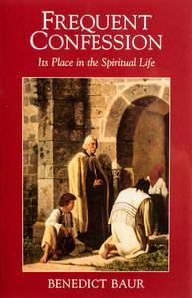
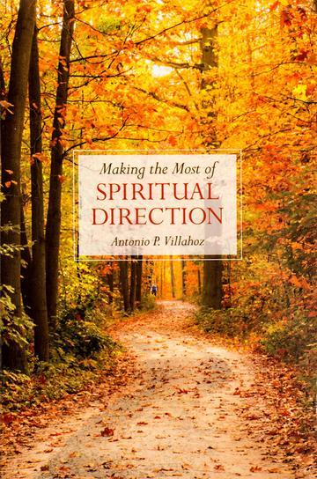
“TO MAKE A GOOD RETREAT…”

16

We want to help you become a saint every day, from right where you are and share Christ with others.
Have you ever tasted the beauty of God’s presence? It's natural to want to experience his closeness more often—as often as you can! As St. Josemaría Escrivá said: “Either we learn to find our Lord in ordinary, everyday life, or else we never find Him.”
We can help you discover and grow closer to God every day in your work, family life, and other ordinary activities. We want you to become a saint and everything we publish and do is directed towards that goal.
Thank you
Thank you for reading the booklet. Please feel free to redistribute the booklet to anyone who might benefit from it. If you are interested in similar reading, see the related books below.

CATHOLIC BOOKS FOR SPIRITUAL GROWTH

